**Admin Panel**

**Admin Panel > Search Bar**

* **When I entered a product name that already ordered, I can see that when I click product button but I can not see that when I click the order button.**
* **When I entered OID.17 to the search button, there Is no order comes up.**
* Everything I mean, when we put a keyword down, we should be able to search from style numbers, titles, contents etc without choosing the search type **– NOT DONE**
* We should be able to search customers, orders, products etc **– NOT DONE**

**Admin Panel > Orders – POINT 1**

* **Customer Name** should be **Retailer Name,** **–DONE**
* This should show the Business Name of the retailer not person name **– NOT DONE**

**Admin Panel > Orders > View POINT 1A**

* when I click download button, I should be able to download the invoice (same invoice that we have created on order confirmation page), **– NOT DONE**
  + **Please put our Logo on downloadable pdf**
* when I click edit, I should be able to edit the order and should be able to update the colour, size, status and quantity of each order (see below) **– NOT DONE**

Order Confirmation page & PDF Download and Print should include the **quantity** ordered and **total price** as well. **– NOT DONE**

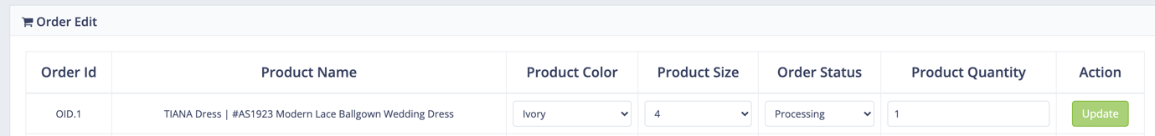

**Admin Panel > Orders > Orders Today POINT 1B**

**Only add RETAILER ID on the left when we click orders today, orders this month and orders last month.**

**Also change order today to Today’s Orders, Order this month to (This Month’s Order), Orders last month to (Last Month’s Order)**

**Admin Panel > Orders > Orders This Month POINT 1C**

The latest orders should be at top, and earlier orders should be down on this panel

**(Same as POINT 1B)**

**Admin Panel > Orders > Orders Last Month POINT 1D**

The latest orders should be at top, and earlier orders should be down on this panel

**(Same as POINT 1B)**

**Admin Panel > Products POINT 2**

* Top Sell Products shows 0 can you fix? {Top sell products are those whose total sale is more than or equal to 10 quantity.}
* When we click to add or edit product
  + We must have unique Barcode section just after Style Number (please make that unique in database so, if we used that barcode in any listing, it should show an error with the link of the product that barcode used to let us know where we used that barcode.

**Admin Panel > Edit Main Page > User Contact Request**

Put this user contact request right side of Chat, so when we receive a request, we can see numbers of requests like chat works

* When we receive a contact request, we should have the numbers in the circle showing on the right side of Contact Request so we know someone wants to contact us

**Also chat should have the same think. (You have done it previously so when a retailer wanted to contact us, admins and retailers was seeing numbers of the requests on right side of the text so we knew people wants to contact us.**

**Admin Panel > Edit Main Page > Manage Custom Page**

**When we adding new page,**

1. When we add a page name **Test Page,**
   1. When I create a page, content comes automatically and asks me to edit, I want HTML content field (like the one you made for email templates) So I can add my content instead of a content of front page loading automatically.
   2. Just above Page Keywords, I need page Title section as well so I can create my page title.

**When we editing a page,**

1. When I click edit a page, I should be able to edit the page name, title, keywords and contents as well.
2. When a new product added, a price changed all retailers should receive email notifications. **(admins should be able to edit the email template)** 
   1. **Our template should go above the product details (at the moment, it is below the product details)**
3. When an order received, the email received both admins and retailers should have the Order ID, Product Notes, Style, Price and Status as well.

1. Admins should be able to create new email templates with being able to create attachments (to be saved for that template) under a specific template name and should be able to choose one of the templates created when sending email to retailers in bulk or specific ones.
   1. **Email templates to send bulk email to retailers do not allow to have attachment at the moments.**
2. I want to use Variables such as Business Name, address, phone number, website, Facebook, Instagram of a retailer in my email templates. For example, I want to use subject as the following when I, as an admin, receive a chat request from a retailer {Business Name} has sent you an inquiry, or in content, I want to use something like Dear {Retailer}, Please……..
3. While an order is in pending status (added to card but not paid) retailer should be able to click to direct to checkout from the **reports section - DONE**
   1. if a chart is waiting for 1 day, 7 days and 15 days reminder email should go to retailer with details of products left in chart **– DOES NOT WORK**